**Part Three: Interactive Dashboard Design**

**3.1 Introduction**

This section outlines the objectives of the interactive dashboard project. The main goals are to create a user-friendly platform for comparative analysis of economic and social indicators in selected countries, allowing users to quickly assess and compare different countries across multiple metrics and years.

The dashboard will facilitate the comparison of economic and social indicators across various countries, enabling users to examine variations between nations. It will feature a user-friendly design to ensure accessibility for users with varying levels of data analysis expertise. Users will be able to simultaneously compare multiple metrics, providing a comprehensive view of each country's performance. The dashboard will support the analysis of data across different years, helping users understand trends and developments in these countries. The target audience includes policymakers, and researchers interested in gaining insights into socio-economic conditions.

**3.2 Data Visualization Principles:**

The dashboard design is informed by fundamental data visualization principles that enhance the clarity, effectiveness, and user-friendliness of the platform. Clarity was prioritized in visual representations, following the guidance of Edward Tufte's work on data visualization Tufte emphasizes that simplicity in design, while minimizing chart junk, aids in conveying information effectively.

Appropriate visual encoding methods for data variables were employed, as recommended by Stephen. For instance, use bar charts for comparing quantities and line charts for tracking trends over time. Consistency in design elements, such as colour schemes, labels, and scales, is based on the principles outlined in "The Visual Display of Quantitative Information". Consistency across different visualizations aids users in making connections and understanding the data seamlessly.

Colour usage is influenced by the guidelines proposed in "Show Me the Numbers" by Stephen Few. Colour is employed not only for aesthetic appeal but to convey information, and we avoid using too many colours that can be confusing. The incorporation of interactivity aligns with best practices in modern data visualization. Features like filters, drill-through options, and tooltips enhance the user experience by allowing users to explore the data interactively.

**3.3 Data Pre-processing**

Data pre-processing is a crucial aspect of creating an informative dashboard. Key steps taken to prepare the data for our interactive dashboard:

Data Collection: Relevant datasets were gathered from sources such World Development Indicators (WDI) and United Nations Data Bank (UNdat), encompassing economic and social indicators for various countries over multiple years.

Data Cleaning: To ensure data consistency and reliability missing values, inconsistencies, and standardized units of measurement were addressed.

Data Integration: Data was unified from different sources and years into a single comprehensive dataset for dashboard use.

Data Transformation: Derived metrics were calculated, normalized data for consistent comparison, and improved usability.

Data Aggregation: Data was aggregated at various levels to provide summary information for the dashboard.

Data Export: The data was prepared for the dashboard development tool, structured for efficient querying and visualization. These steps set the foundation for an accurate, consistent, and meaningful dashboard showcasing economic and social indicators of selected countries.

**3.4 Design Rationale**

The design of the interactive dashboard is underpinned by key principles that prioritize user-friendliness, data visualization best practices, and effective communication of socio-economic data. To ensure clear navigation for users’ Single screen layout was opted to provide a structured narrative. A carefully selected colour palette and visual consistency enhance the user experience, while a variety of charts were chosen to match the nature of the data. Interactivity is a vital component, allowing users to customize their analysis with drop-down menus and sliders.

Data attributes are seamlessly mapped to visual forms, enabling users to make quick comparisons and explore trends. Guided user support, including tooltips and information buttons, ensures users can effectively navigate and interpret the data. References to data visualization experts like Edward Tufte and Stephen Few have guided our design choices, emphasizing clarity, simplicity, and user-centric design. In essence, our dashboard is designed to empower a broad audience, including policymakers and researchers, in making data-driven decisions and disseminating knowledge.

* 1. **Visual Paradigm Selection**

A combination of visual paradigms that best serve the objectives of the dashboard were chosen, to enable users perform comparative analysis of economic and social indicators for selected countries. The key visual paradigms employed include:

Bar Charts and Line Charts: Bar charts were used to compare social economic indicators making them suitable for visualizing metrics for specific countries. Line charts were chosen for metrics such as GDP, education enrolment, and life expectancy. This choice aligns with best practices for illustrating trends over time. Line charts offer a clear representation of how these indicators change year by year, enabling users to grasp long-term progress and patterns effectively. These paradigms are rooted in the principles of data visualization put forth by experts like Edward Tufte [Tufte, 1983] and Stephen Few [Few, 2012].

Choropleth maps are geospatial representations that utilize colour gradients to depict data variations across countries on a map. These maps are valuable for displaying geospatial patterns in economic and social data. Works by MacEachren [MacEachren, 2004] and Robinson [Robinson et al., 2011] have influenced our choice.

The selections of line charts and bar charts were made with the intention to provide a clear, intuitive, and consistent representation of the selected socio-economic indicators, ensuring that the dashboard will be both informative and user-friendly

**3.5 Conceptual Model**

A crucial aspect of effective dashboard design is the creation of a coherent and unified conceptual model that seamlessly integrates individual analysis workflows. This section will elaborate on the development of our conceptual model, highlighting how it merges distinct data visualization elements into a single view that empowers users to gain meaningful insights through the principles of focus and context.

**3.5.1 Integration of Individual Workflows**

The dashboard design is founded on the integration of individual analysis workflows. Each socio-economic indicator has its unique storyline to tell, but the challenge lies in presenting these narratives in a manner that facilitates easy interpretation and comparison. To address this challenge, a screenshot layout that accommodates the representations of different indicators without overwhelming the users is incorporated. This approach ensures that the user can focus on specific details while maintaining a contextual understanding of the overall socio-economic landscape.

**3.5.2 Unified Narrative**

The conceptual model revolves around the creation of a unified narrative that connects the different workflows, thus promoting a holistic understanding of the data. This narrative is designed to follow the principles of focus and context, where users can seamlessly transition between a detailed view of specific countries and years and a broader view that encompasses the entire dataset.

**3.5.3 Focus Context Principles**

The conceptual model is driven by the principles of focus and context, a technique frequently applied in data visualization to support comprehensive data exploration. It enables users to delve into specific aspects (focus) while retaining an awareness of the broader dataset context.

**3.5.4 Illustration**

To provide a visual representation of the conceptual model, a screenshot that demonstrate how different elements interconnect within the dashboard. This will aid in understanding the flow and functionality of the dashboard, emphasizing how users can traverse between detailed insights and the overall socio-economic landscape seamlessly.

The following Screenshot illustrates the core components of our conceptual model:

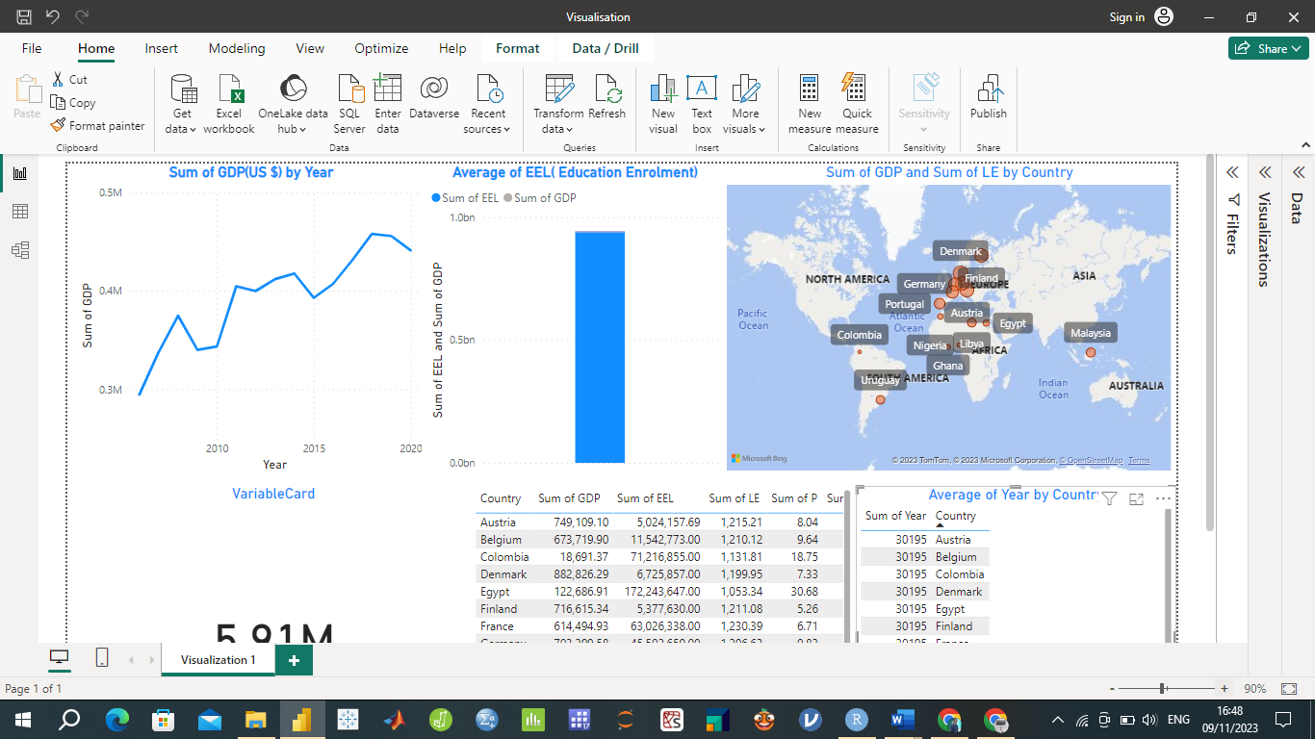

The conceptual model serves as the foundation for the interactive dashboard design, effectively guiding users in their exploration of socio-economic indicators for selected countries.

**Discussion and Conclusion**

This section critically evaluates the approaches and proposal formed throughout the development of interactive dashboard. Key aspects, including methodology, individual digital workflows, and the final composited dashboard are reviewed.

The Methodology for developing the dashboard consisted of several crucial stages. First was extensive data collection from reputable sources including World Development Indicators (WDI) and United Nations Data Bank (UNdat). The data cleaning process ensured high data integrity. Integration and transformation were essential for creating a unified dataset effectively utilized in the dashboard.

The project involved individual digital workflows for each socio-economic indicator, allowing users to explore and compare indicators across different countries and years. The use of line charts for showing the sum of each indicator over time provided a clear visual representation. The accompanying bar graphs offered a side-by-side comparison of these indicators. The maps allowed users to visualize the distribution of indicators across countries.

The composited dashboard effectively brings together these individual workflows into a single, coherent visual representation, such that Users can easily switch between indicators, and the "focus+context" principle is applied through the integration of various visualizations, including line charts, bar graphs, and maps. This provides a meaningful and comprehensive view of the socio-economic indicators of the selected countries.

In conclusion, the proposed solution successfully meets the objectives set out by the briefing document. The dashboard provides a user-friendly platform for the comparative analysis of economic and social indicators for a selection of countries across multiple years. Users can quickly assess and compare the performance of different countries in terms of GDP, education enrolment, poverty headcount, unemployment, population growth rate, and life expectancy. The design of the dashboard is informed by key data visualization principles, ensuring clarity, effectiveness, and user-friendliness. It follows best practices in data visualization, such as using appropriate chart types and colour coding for improved understanding. The "focus context" principle is applied through the integration of various visualizations, giving users both an overview and the ability to delve into specific data points.

The dashboard caters to a wide audience, including policymakers, researchers, and stakeholders interested in socio-economic conditions. By providing a valuable tool for data-driven decision-making and knowledge dissemination, the dashboard fulfills its objectives effectively. It offers a comprehensive view of socio-economic indicators, empowering users to make informed comparisons and gain insights into global trends and disparities.